**Task-1:**

**Unix is great OS. Unix is opensource. Unix is free OS.**

**learn operating system.**

**Unix ,Linux which one you choose.**

**Unix is easy to learn. Unix is a multiuser OS. Learn Unix .Unix is a powerful.**

**1.create a directory and copy this content to a file named file1.txt**

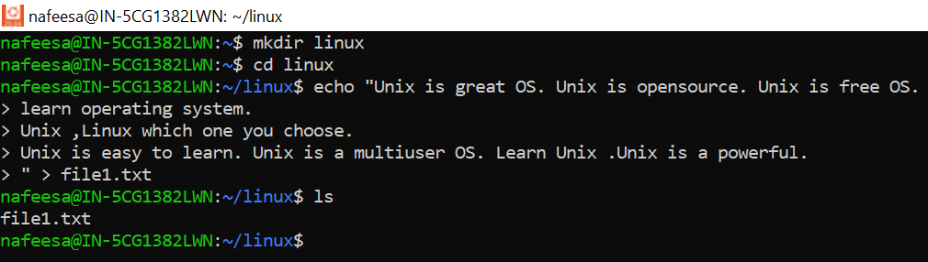

**2.Replace Unix into Linux in the 3rd line and print only the replaced line.**

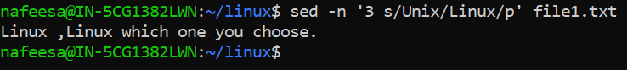

**3.Create two user with case sensitive(example , 1st user name : raj , 2nd user name : Raj) and display both users.**

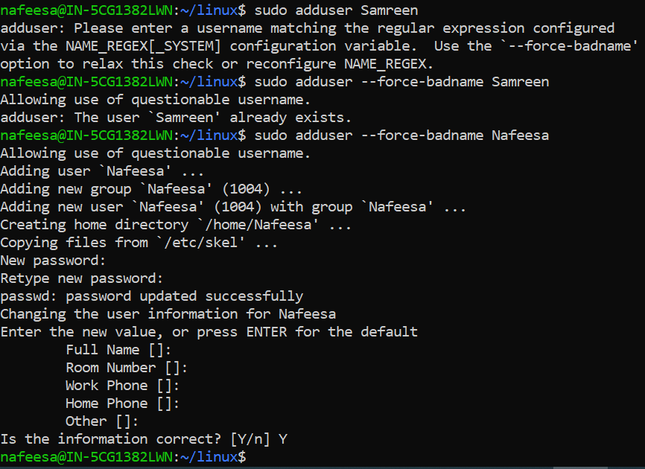

* **By using the command cat /etc/passwd we can check the user created or not.**

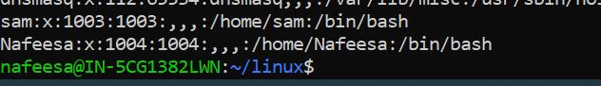

**4.Write a shell script to get the current date ,time ,username and current working directory**

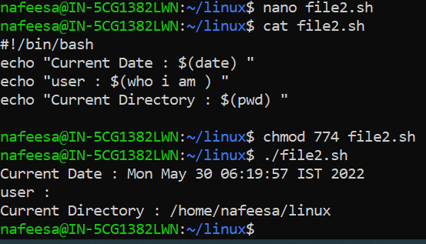

**5.Write a shell script to take input from user and print the input along with the given sentence.**

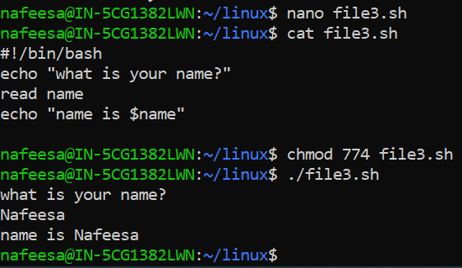

**6.Create a file having some numbers and find the sum of all the numbers in the file.**

**-> By using the command cat > <filename> in that enter the numbers u like .**

**->Then by using the nano editor write the below script in that new script file.**

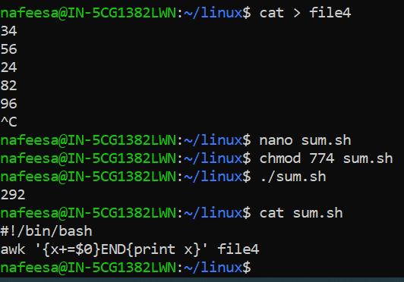

**7.Write a command to print the line number before each line.**

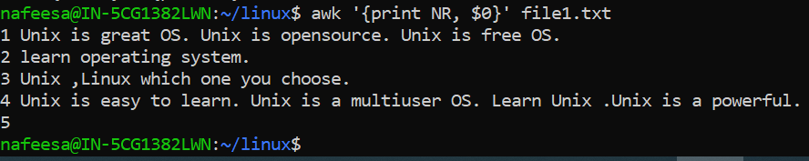

**8.List the users who have logged into the system currently.**

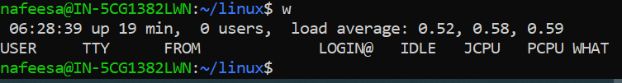

**9.Create a file and display file permission. Give read, write and execute permission to others.**

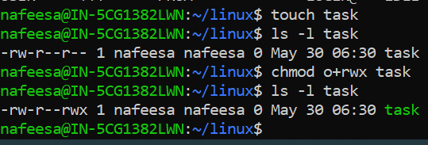

**Task-2:**

**2) Install latest version of Nginx in Ubuntu and host your test web application(Just**

**a) Access above hosted application from browser**

**b) Share a screenshot of nginx latest access log and error log**

**-> Installing nginx server on Amazon Linux**

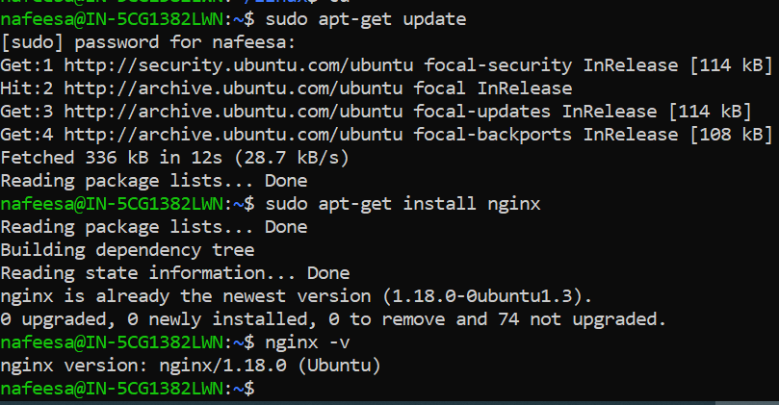

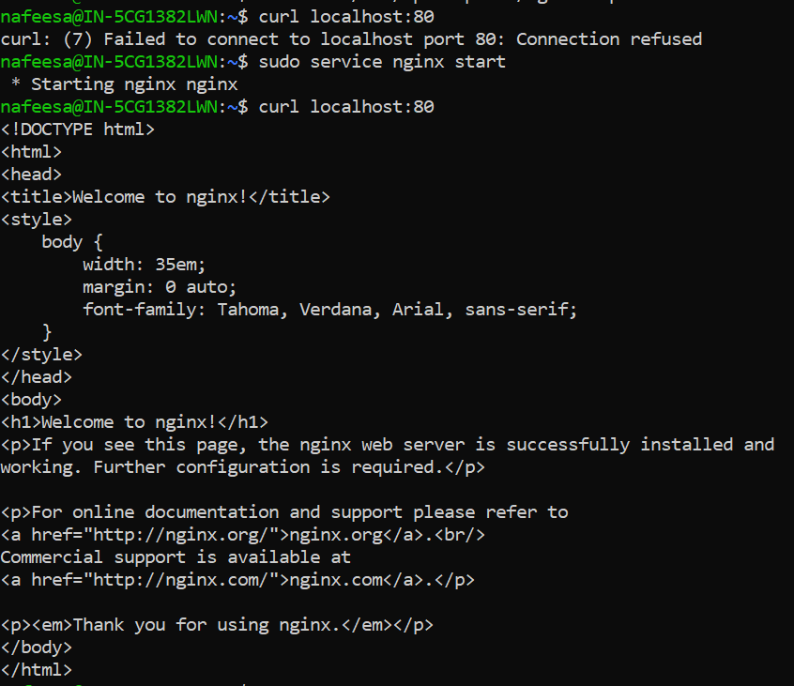

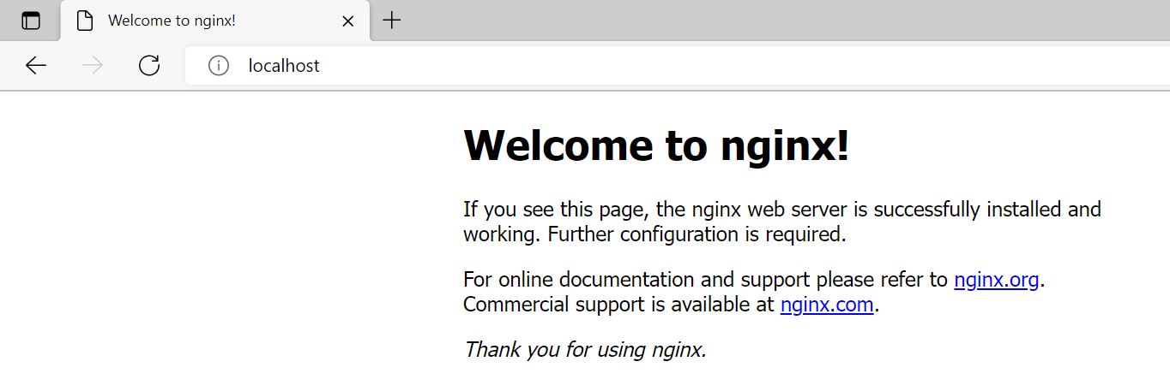

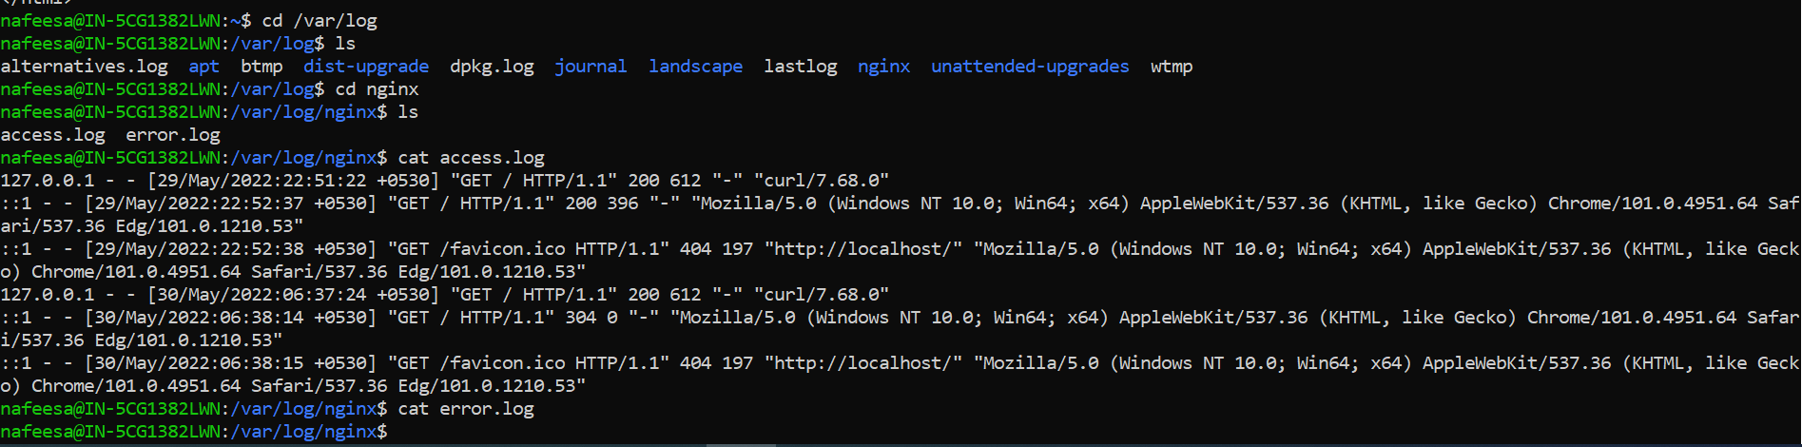

**4) Install docker and docker compose in same server your test web application is hosted(Nginx).**

**a) Run a nginx docker container**

**b) Host different html file in nginx container**

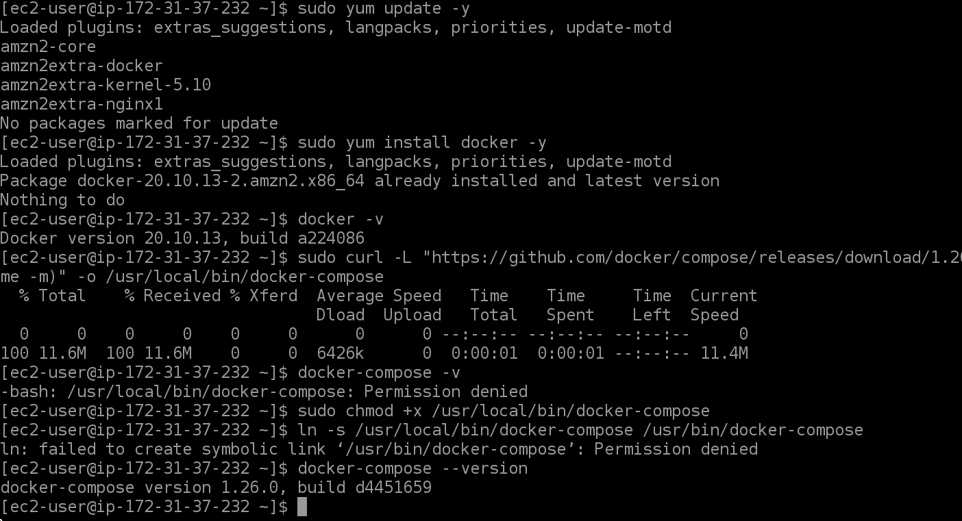

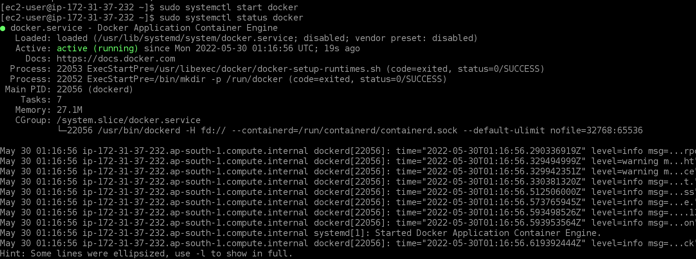

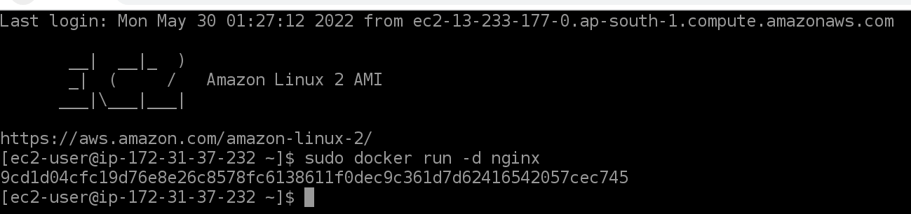

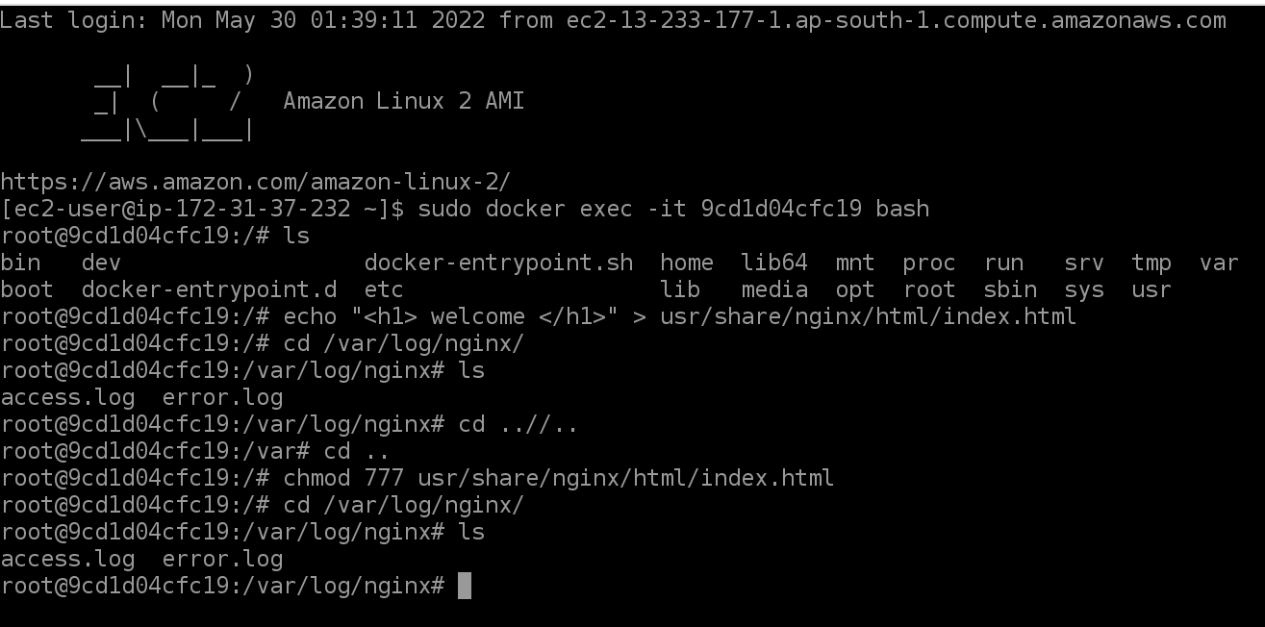

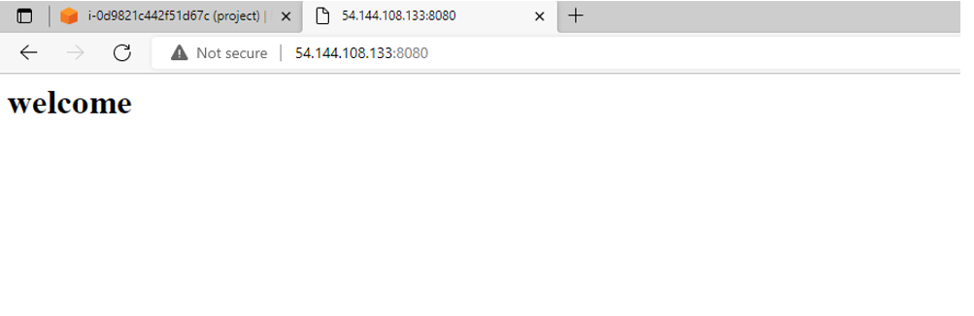

**Task-3:**

**1) Linux script to create 100 text files in a directory and put below text in each files.**

**Test to add in files:-**

"Contemporary climate change includes both global warming and its impacts on Earth's weather patterns.

There have been previous periods of climate change, but the current changes are distinctly more rapid

and not due to natural causes. Instead, they are caused by the emission of greenhouse gases, mostly

carbon dioxide (CO₂) and methane. Burning fossil fuels for energy use creates most of these emissions."

**->Create a file by using nano editor and type the code**

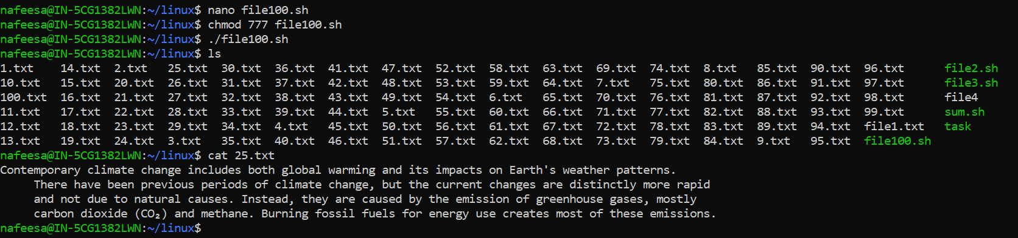

**2) Zip the above directory in tar.gz format and copy it to /opt/ directory.**

**a) Unzip your tar.gz file in /opt/ directory and delete 50 files from it.**

**b) Zip the directory again with same name**

**->**Tar all the files containing directory by using tar -czvf <filename>.tar.gz

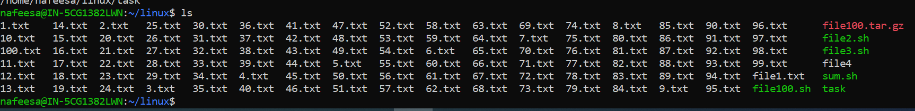

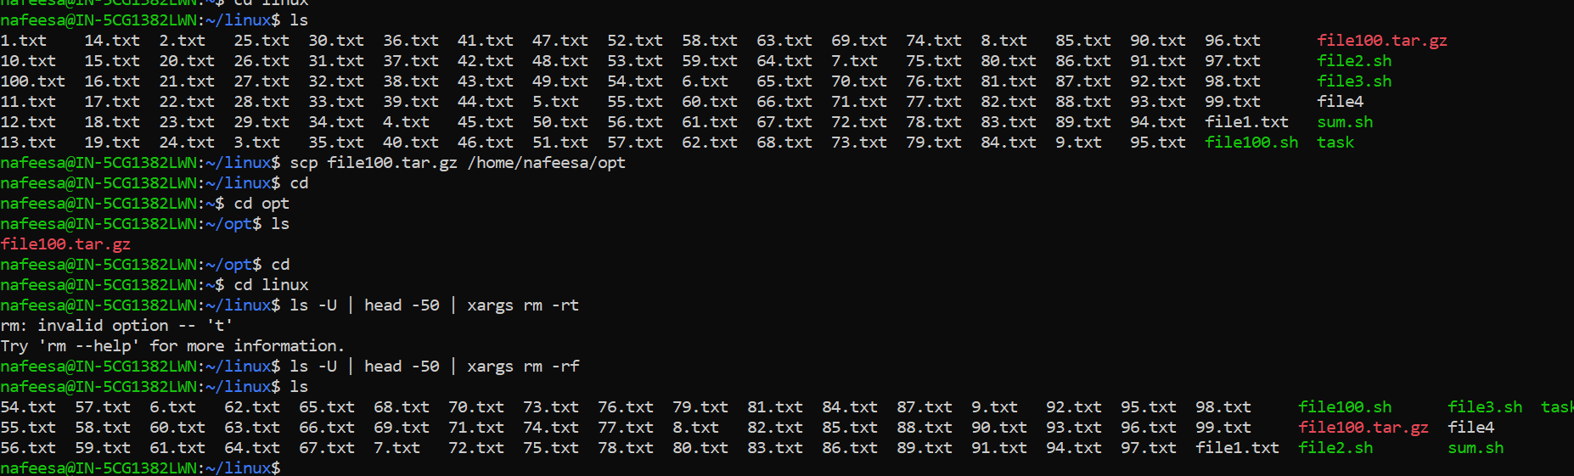

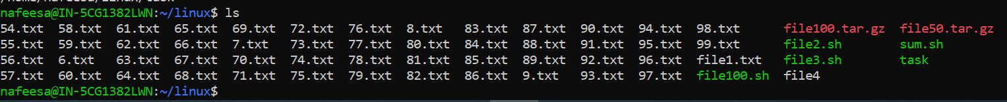



**3) Linux command to find "yum.conf" file with file size.**

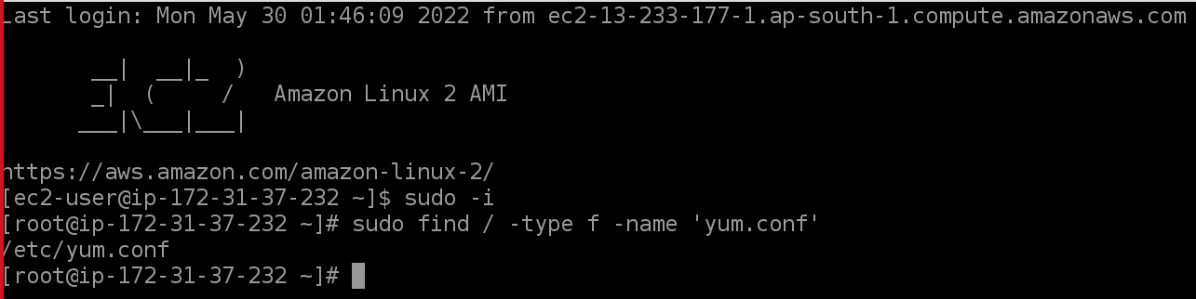

**4) Please check the reachability of below domains and IP and share the output**

www.google.com

[www.facebook.com](http://www.facebook.com)

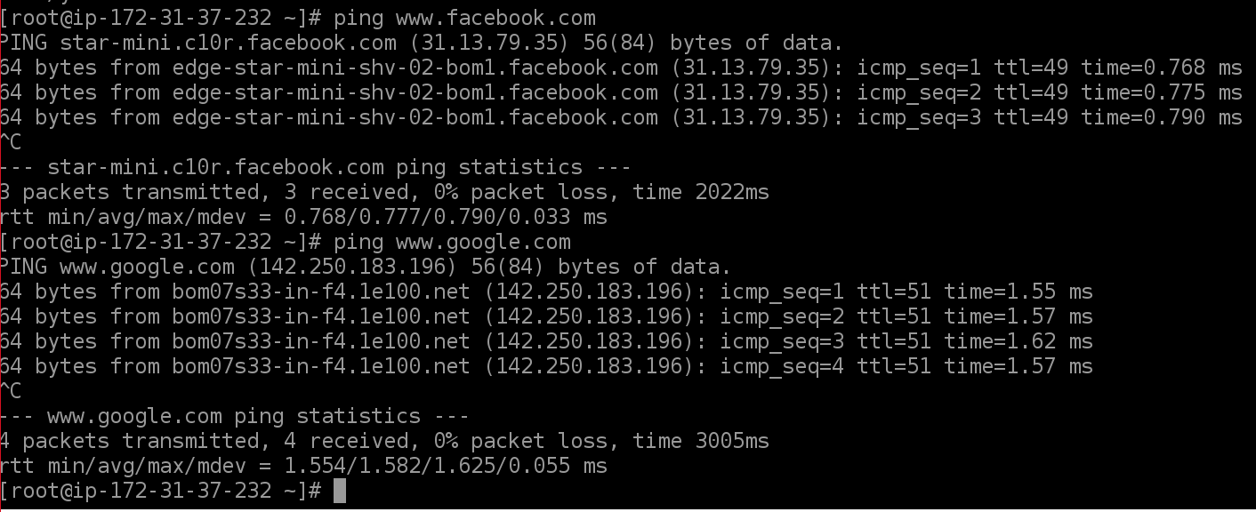

192.168.0.1 www.youtube.com

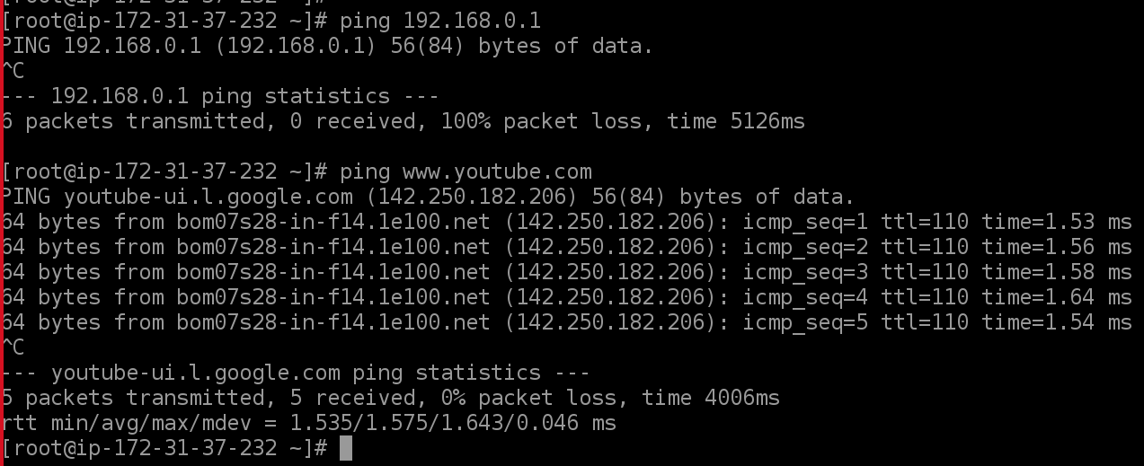

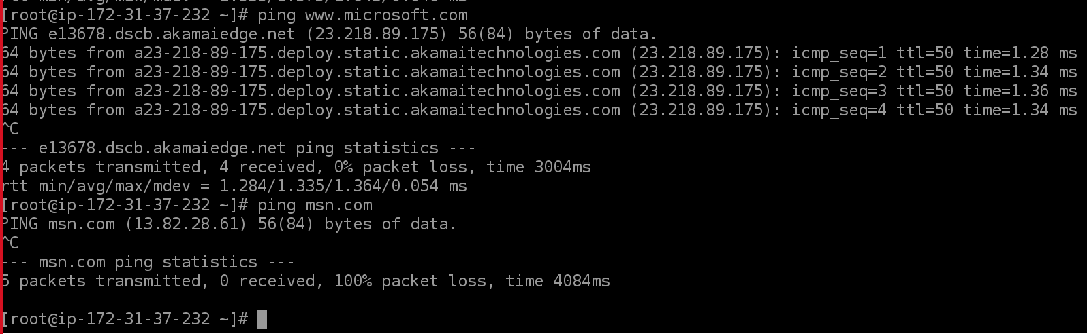

**Task-4:**

**1)Install Nginx web server in your linux server and execute a command to check Nginx server listening port and share the screenshot**

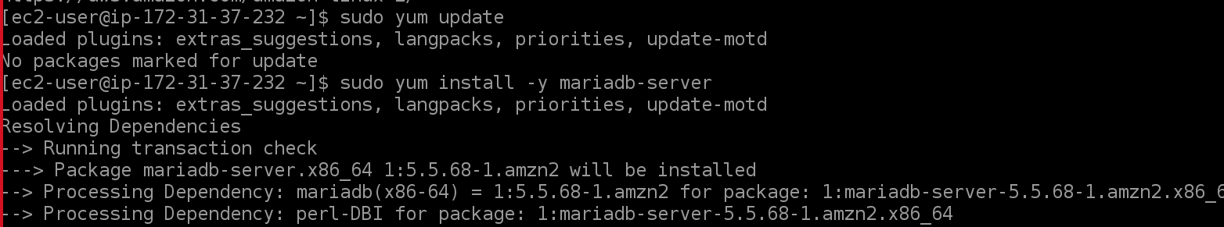

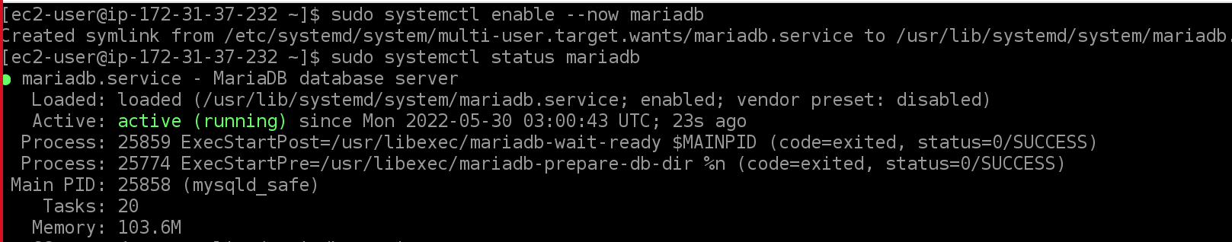

**Enter the command shown in below snip and then it will ask (enter for non) hit enter and type the password you prefer and give yes for all and at the end you will get Thanks for using MariaDB!**

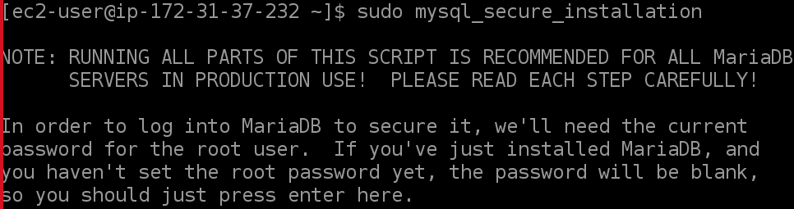

**After installing give the below command and enter the password you given and then give show databases; command**

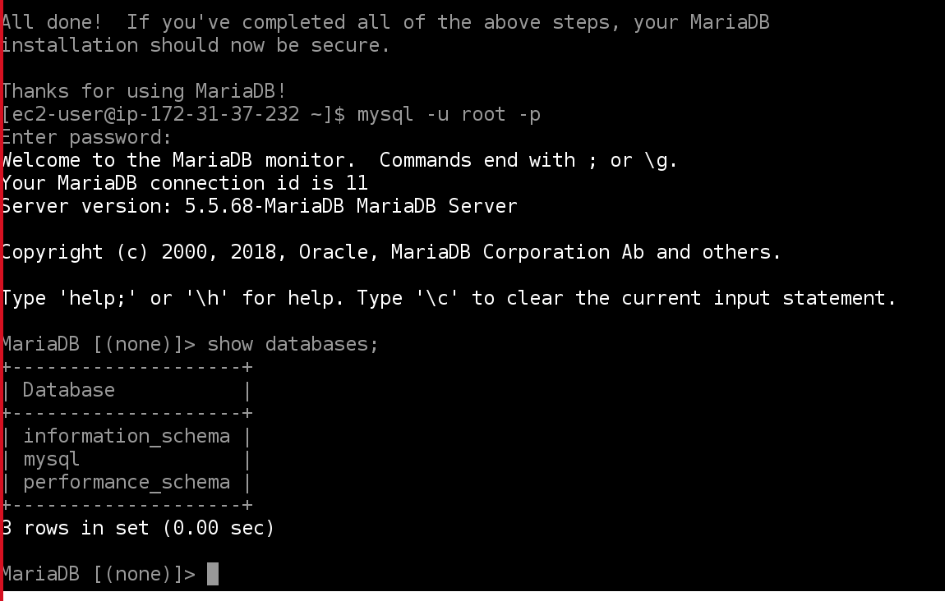

**2) Install and configure Mysql database**

**a) Restore shared database dump file to your database and check data’s and tables are restored successfully (Please check the attachment of database dump file)**

**b) Create a bash script to back up your database. Your backup name should be like "yourdatabasename-date and time" format**

**c) Put above script in crontab to run every 5 minutes and check.**

**Open powershell and check the version of GIT and u need to have a dump file and add that file by using git add command.**